**Periodic Table Program documentation**

*Elemental V0.1

*First 20 elementals useable

*Ionic bonds added

*Covalent bonding not supported

*Metal alloys unsupported

**Developers : Craig Edwards**

Developed using third party library QT.

**Key files include :**

* icudt52.dll
* icuin52.dll
* icuuc52.dll
* libEGL.dll
* libGLESv2.dll
* Qt5Core.dll
* Qt5Gui.dll
* Qt5Widgets.dll
* Microsoft visual C++ 2010 redistributable
* moc_periodictable.cpp
* moc_periodictable.obj
* PeriodicTable.exe
* Plugins folder

**Functions explanations**

void on_Lanathanide_Series_clicked();

void on_Actinide_Series_clicked();

The functions above expand the table to show the extra elements.

void on_H_clicked();

void on_He_clicked();

void on_Li_clicked();

void on_Be_clicked();

void on_B_clicked();

void on_C_clicked();

void on_N_clicked();

void on_O_clicked();

void on_F_clicked();

void on_Ne_clicked();

void on_Na_clicked();

void on_Mg_clicked();

void on_Al_clicked();

void on_Si_clicked();

void on_P_clicked();

void on_S_clicked();

void on_Cl_clicked();

void on_Ar_clicked();

void on_K_clicked();

void on_Ca_clicked();

The Above functions give a result when a button is clicked. Example possible ionic bonds with Carbon is highlighted when void on_C_clicked() is called.

void on_resetButton_clicked();

The above function resets the program to default state when the reset button is clicked

void on_fuseButton_clicked();

The above function generates the compound result of the 2 selected elements

**Program variables and constants**

boolean downed variable is used to contain a true or false value whether a button is pressed down or not. It is true if the button is down and false if it is not pressed.

pointers QFont *f, *f2 is a QT pointer which containers fonts which are set to the element ID.

pointer *ui is used to dereference the Form user interface and all its objects.

**Instructions**

1. Open release folder.

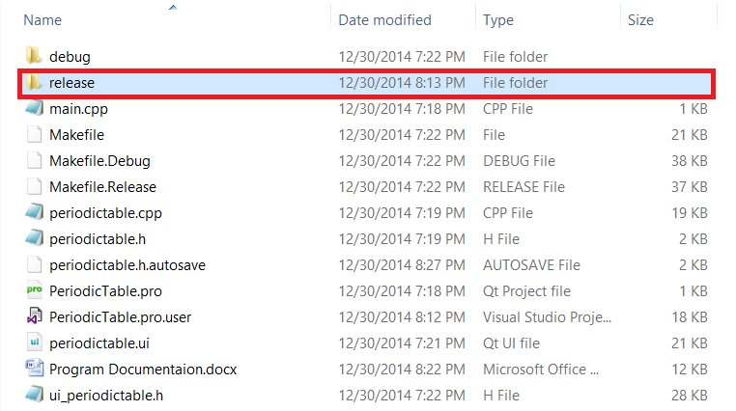

2. Install vcredist_x86.exe if not already installed.

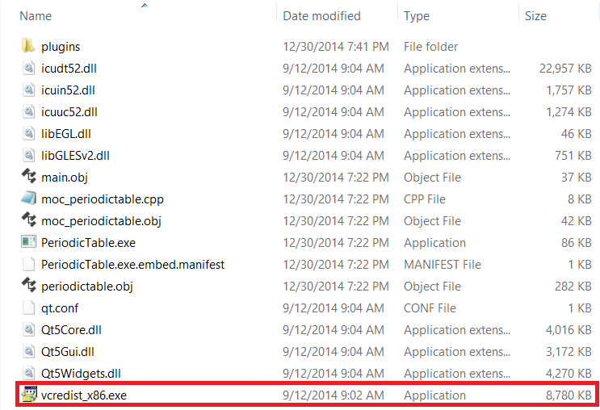

3. Run PeriodicTable.exe

4. Select a metal and possible ionic bonds should be highlights (metal + non-metal)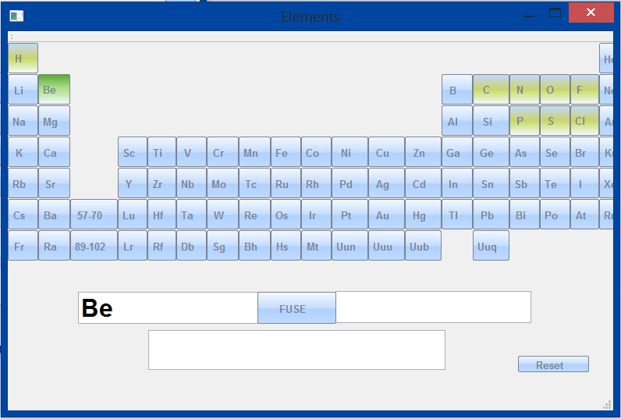

5. Select a another element (non-metal) from highlighted elements and click fuse to show bond result

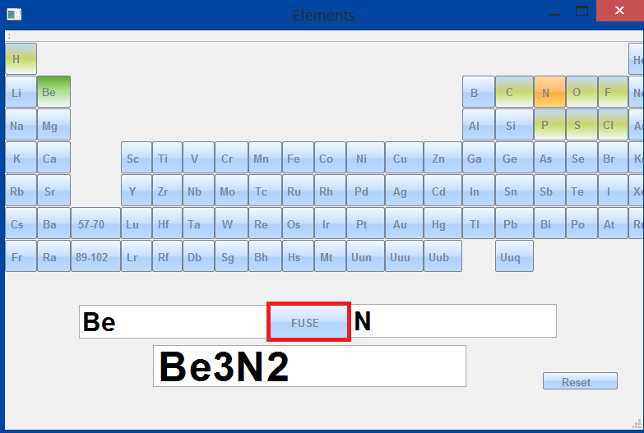

6. Press Reset button to restart the program or simply select another element and fuse again.

7. Click 57-70 or 89-102 to expand table

